**Code 4: Form**

Code:

<!DOCTYPE html>

<html>

<head>

<title>Form</title>

<style>

.buttons{

background-color: burlywood;

border: 1px;

border-radius: 8px;

padding: 6px 12px;

}

h1{

text-align: center;

}

th,td,b{

color: darkolivegreen;

}

.hw,select{

border-radius: 20px;

height: 25px;

width: 300px;

}

th,td{

font-size: 30px;

}

input[type=radio]{

border: 0px;

width: 50px;

height: 2em;

}

input[type=submit],input[type=reset]{

width: 120px;

height: 40px;

font-size: large;

}

</style>

</head>

<body bgcolor="cyan">

<h1>FORM</h1>

<form>

<table>

<tr>

<th>First Name:</th>

<td><input type="text" class="hw"></td>

</tr>

<tr>

<th>Last Name:</th>

<td><input type="text" class="hw"></td>

</tr>

<tr>

<th>Username:</th>

<td><input type="text" class="hw"></td>

</tr>

<tr>

<th>Password:</th>

<td><input type="password" class="hw"></td>

</tr>

<tr>

<th>Birthday:</th>

<td><input type="date" class="hw"></td>

</tr>

<tr>

<th>Gender:</th>

<td><input type="radio" name="gender" value="male" class="hw1"> Male <input type="radio" name="gender" value="female" class="hw1"> Female</td>

</tr>

<tr>

<th>Location:</th>

<td>

<select name="Location" class="hw">

<option value="Andhra Pradesh">Andhra Pradesh</option>

<option value="Andaman and Nicobar Islands">Andaman and Nicobar Islands</option>

<option value="Arunachal Pradesh">Arunachal Pradesh</option>

<option value="Assam">Assam</option>

<option value="Bihar">Bihar</option>

<option value="Chandigarh">Chandigarh</option>

<option value="Chhattisgarh">Chhattisgarh</option>

<option value="Dadar and Nagar Haveli">Dadar and Nagar Haveli</option>

<option value="Daman and Diu">Daman and Diu</option>

<option value="Delhi">Delhi</option>

<option value="Lakshadweep">Lakshadweep</option>

<option value="Puducherry">Puducherry</option>

<option value="Goa">Goa</option>

<option value="Gujarat">Gujarat</option>

<option value="Haryana">Haryana</option>

<option value="Himachal Pradesh">Himachal Pradesh</option>

<option value="Jammu and Kashmir">Jammu and Kashmir</option>

<option value="Jharkhand">Jharkhand</option>

<option value="Karnataka">Karnataka</option>

<option value="Kerala">Kerala</option>

<option value="Madhya Pradesh">Madhya Pradesh</option>

<option value="Maharashtra">Maharashtra</option>

<option value="Manipur">Manipur</option>

<option value="Meghalaya">Meghalaya</option>

<option value="Mizoram">Mizoram</option>

<option value="Nagaland">Nagaland</option>

<option value="Odisha">Odisha</option>

<option value="Punjab">Punjab</option>

<option value="Rajasthan">Rajasthan</option>

<option value="Sikkim">Sikkim</option>

<option value="Tamil Nadu">Tamil Nadu</option>

<option value="Telangana">Telangana</option>

<option value="Tripura">Tripura</option>

<option value="Uttar Pradesh">Uttar Pradesh</option>

<option value="Uttarakhand">Uttarakhand</option>

<option value="West Bengal">West Bengal</option>

</select>

</td>

</tr>

</table>

<input type="radio" name="TnC" id="tnc" class="hw1"><b>I agree to the terms and conditions.</b>

<p>

<input type="submit" class="buttons"> <input type="reset" class="buttons">

</p>

</form>

</body>

</html>

Output:

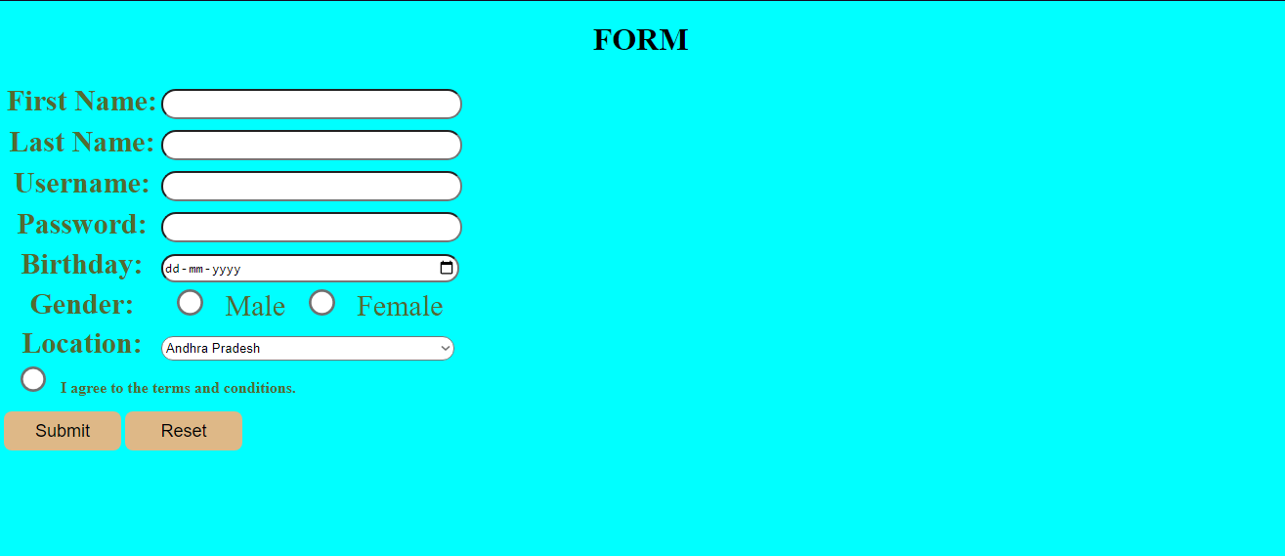

**Code 5:Indian Food**

Code:

<!DOCTYPE html>

<html>

<head>

<title>

Indian Food

</title>

<style>

td,th{

width:auto;

height: auto;

vertical-align: top;

padding: 5px 10px;

}

table{

border-collapse: collapse;

margin-left: auto;

margin-right: auto;

}

p,a,td,th{

font-size: 20px;

color: #c6c096;

}

h1{

color: #c7d0d7;

}

h2{

color: #f3b6b6;

}

</style>

</head>

<body bgcolor="#FFD7D7">

<h1 style="text-align: center;"><u>INDIAN FOOD</u></h1>

<p >

The traditional food of india has been widely appreciated for its fabulous use of herbs and

spices. Indian cusine is known for its large assortment of dishes. the cooking style varies from

region and its largely divided into South Indian and North Indian cusine. India 1s quite famous

for its diversemulti cuisine available in a large number of resturants and hotel resorts which is

reminiscent of unity in diversity.

</p>

<p style="text-align: right;">

<a href="#tbl">Available Food</a><br>

<a href="because-not-decided">Dishes Price</a><br>

<a href="https://recipes.timesofindia.com">Get Recipies</a>

</p>

<img src="https://thumbs.dreamstime.com/b/indian-food-curry-butter-chicken-palak-paneer-chiken-tikka-biryani-vegetable-curry-papad-dal-palak-sabji-jira-alu-rice-138549925.jpg" alt="food images" style="border-radius: 20px;height: 550px;">

<img src="https://www.youngisthan.in/wp-content/uploads/2021/03/5cbc5ded512c0c3e8b6c782d_1555848685957-970x1213.jpg" alt="india-map-made-with-food" style="border-radius: 3000000px;width: 445px;">

<h2 style="text-align: center;">Select Dishes</h2>

<table border="1px" id="tbl">

<tr>

<th>State</th>

<td>Gujarat</td>

<td>Punjab</td>

<td>Tamil Nadu</td>

</tr>

<tr>

<th>Dishes</th>

<td>

Khandvi <br>

Dhokhla <br>

Dal Vada

</td>

<td>

Falooda <br>

Naan <br>

Lassi

</td>

<td>

Masala Dosa <br>

Sambhar Idli <br>

Upma

</td>

</tr>

</table>

<p style="text-align: center;">

<a href="https://www.zomato.com/">Click here to order</a>

</p>

</body>

</html>

Output:

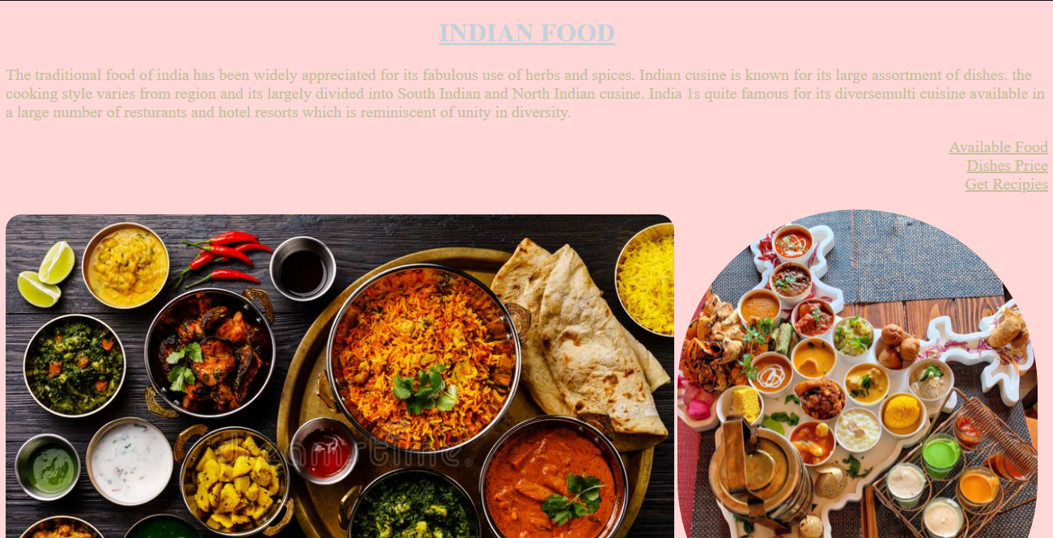

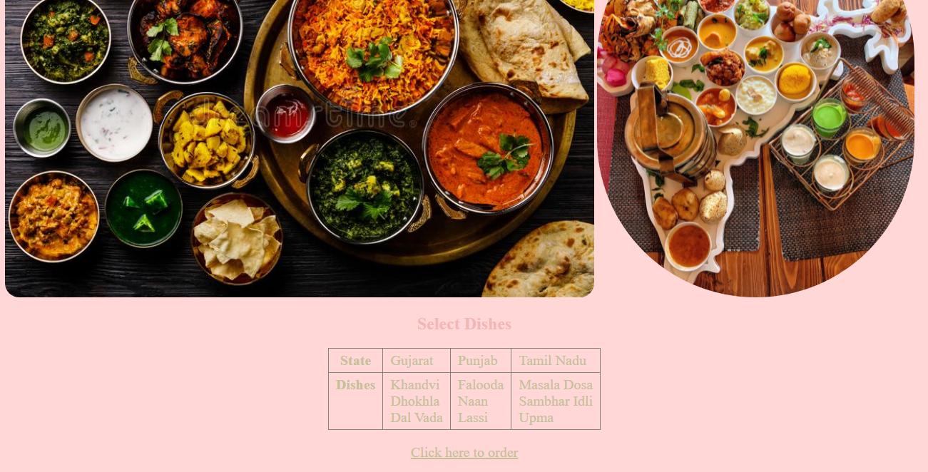

**Code 6: Save Earth**

Code:

<!DOCTYPE html>

<html>

<head>

<title>Save Earth</title>

<style>

table{

border-collapse: collapse;

margin-left: auto;

margin-right: auto;

}

th,td{

text-align: center;

padding: 6px 12px;

font-size: 20px;

}

dd{

font-size: 20px;

}

dt{

font-size: 18px;

}

li{

font-size: 17px;

}

a{

text-decoration: none;

}

dt{

color: rgb(255, 255, 255);

}

dd,table{

color: rgb(67, 98, 236);

}

</style>

</head>

<body bgcolor="grey">

<h1 style="text-align: center;color: rgb(248, 181, 56);">Save Earth,Save Life</h1>

<p style="font-size: 18px;color: cyan;"> Earth is the third planet from the Sun, and the

densest and fifth-largest of the eight planets in

the solar System. Earth’s only known natural satellite,

the Moon, which began orbiting it about 4.53 billion

years ago, provides ocean tides, stabilizes the axial

tilt, and gradually slows the planet’s rotation.

</p>

<img src="https://images-na.ssl-images-amazon.com/images/I/51b%2BMu-dh-L._SL1000_.jpg" alt="save-earth" style="height: 400px;width: auto;border-radius: 200px;">

<img src="https://us.123rf.com/450wm/stori/stori1804/stori180400068/99723709-ecological-concept-of-the-environment-with-the-cultivation-of-trees-on-the-ground-in-the-hands-plane.jpg?ver=6" alt="Image-Save-Earth" style="height: 400px;width: auto;border-radius: 100px;">

<img src="https://m.media-amazon.com/images/I/51L--KMbvsL._SL1000_.jpg" alt="Save-earth-img-3" style="height: 400px;width: auto;border-radius: 8px;"><br><br>

<table border="1px">

<tr>

<th colspan="3">HAZARDS AFFECTING GLOBAL WARMAING</th>

</tr>

<tr>

<td><li><a href="#Pol">Pollution</a></li></td>

<td><li><a href="#Glo">Global Warming</a></li></td>

<td><li><a href="#Aci">Acid Rain</a></li></td>

</tr>

</table><br><br>

<dl>

<dd id="Pol"><b>Pollution</b></dd>

<dt>

<p>Pollution is the toxins that mix in the natural environment and harm both human beings and animals. Plants also get affected by pollution. There are many forms of pollution, like air, water, soil, and noise pollution. However, there are other forms of pollution, light pollution, radioactive pollution, and so on. Natural and human activities both contribute to pollution. Volcanic eruptions or oil and gas leakage can cause pollution.</p>

<p>Human activities cause most of the pollution. It is because of the commercialization of natural things. Humans turn many natural things into human-made things to satisfy their needs. We use more than our needs, which adversely affects nature. The gases from vehicles and factories pollute the air. The land and water are polluted by solid garbage from factories, households, and so on. In rural areas, agricultural wastes, pesticides cause pollution. The noise pollution is caused by the massive sound of music, vehicles, and machinery. The pollution also leads to global warming.</p>

<p>We cannot completely remove pollution, but we can surely reduce it by implementing a few preventive measures.</p>

<p>To increase oxygen in the air and make the air pure, we must plant trees on a large level. We should use natural things judiciously. We have to understand the difference between need and want. To decrease the level of land and water pollution, we must avoid using plastic bags. We should use vehicles less to decrease air pollution and noise pollution. We should maintain a proper drainage system to protect the water from getting polluted. We cannot stop natural activities, but we can control our actions. If we do so, we can minimize the impacts of pollution in nature. </p>

</dt><br><br>

<dd id="Glo"><b>Global Warming</b></dd>

<dt>

<p>Global warming or climate change has today become a major threat to the mankind. The Earth’s temperature is on the rise and there are various reasons for it such as greenhouse gases emanating from carbon dioxide (CO2) emissions, burning of fossil fuels or deforestation.</p>

<p>The rise in the levels of carbon dioxide (CO2) leads to substantial increase in temperature. It is because CO2 remains concentrated in the atmosphere for even hundreds of years. Due to activities like fossil fuel combustion for electricity generation, transportation, and heating, human beings have contributed to increase in the CO2 concentration in the atmosphere.</p>

<p>Recent years have been unusually warm, causing worldwide concern. But the fact is that the increase in carbon dioxide actually began in 1800, due to the deforestation of a large chunk of North-eastern American, besides forested parts of the world. The things became worse with emissions in the wake of the industrial revolution, leading to increase in carbon dioxide level by 1900.</p>

<p>According to the Intergovernmental Panel on Climate Change (IPCC), global temperature is likely to rise by about 1-3.5 Celsius by the year 2100. It has also suggested that the climate might warm by as much as 10 degrees Fahrenheit over the next 100 years.</p>

<b style="color: bisque;">Impacts of Global Warming</b> <ul>

<li>The sea levels are constantly rising as fresh water marshlands, low-lying cities, and islands have been inundated with seawater.</li>

<li>There have been changes in rainfall patterns, leading to droughts and fires in some areas, and flooding in other areas.</li>

<li>Ice caps are constantly melting posing a threat to polar bears as their feeding season stands reduced.</li>

<li>Glaciers are gradually melting.</li>

<li>Animal populations are gradually vanishing as there has been a widespread loss of their habitat.</li>

</ul>

<p>As per Kyoto protocol, developed countries are required to cut back their emissions. There is a need to reduce coal-fired electricity, increase energy efficiency through wind and solar power, and also high efficiency natural gas generation</p>

</dt><br><br>

<dd id="Aci"><b>Acid Rain</b></dd>

<dt>

<p>Acid rain, or acid deposition, is a broad term that includes any form of precipitation with acidic components, such as sulfuric or nitric acid that fall to the ground from the atmosphere in wet or dry forms. This can include rain, snow, fog, hail or even dust that is acidic.</p>

<p>Acid rain results when sulfur dioxide (SO2) and nitrogen oxides (NOX) are emitted into the atmosphere and transported by wind and air currents. The SO2 and NOX react with water, oxygen and other chemicals to form sulfuric and nitric acids. These then mix with water and other materials before falling to the ground.</p>

<p>While a small portion of the SO2 and NOX that cause acid rain is from natural sources such as volcanoes, most of it comes from the burning of fossil fuels. The major sources of SO2 and NOX in the atmosphere are:</p>

<ul>

<li>Burning of fossil fuels to generate electricity. Two thirds of SO2 and one fourth of NOX in the atmosphere come from electric power generators.</li>

<li>Vehicles and Heavy Equipments</li>

<li>Manufacturing, oil refineries and other industries.</li>

</ul>

<p>Winds can blow SO2 and NOX over long distances and across borders making acid rain a problem for everyone and not just those who live close to these sources. </p>

</dt>

</dl>

</body>

</html>

Output:

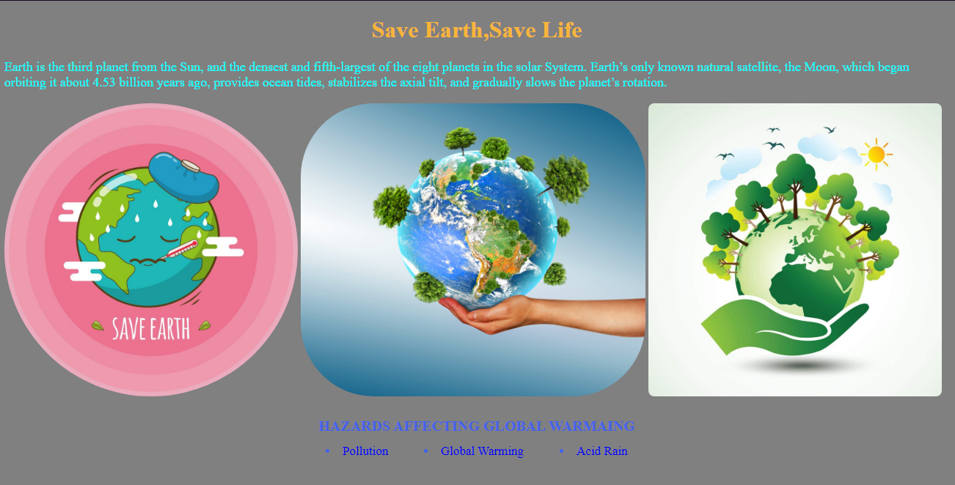

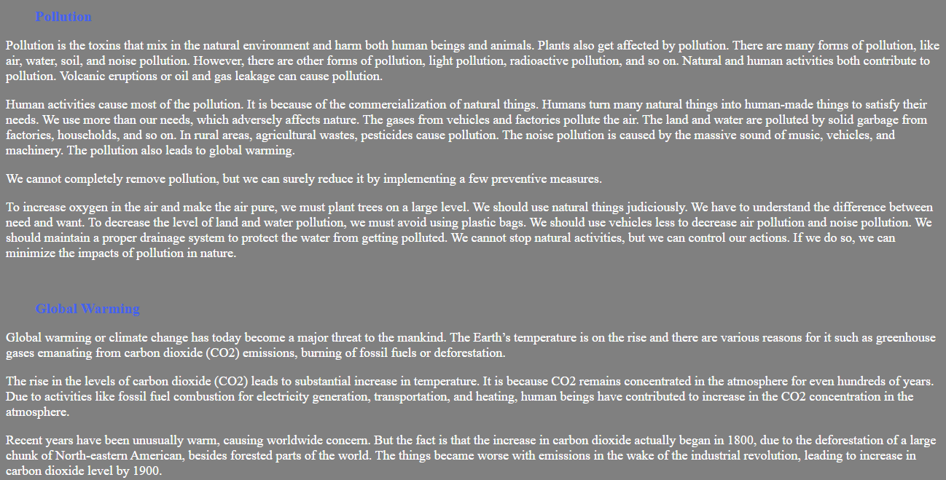

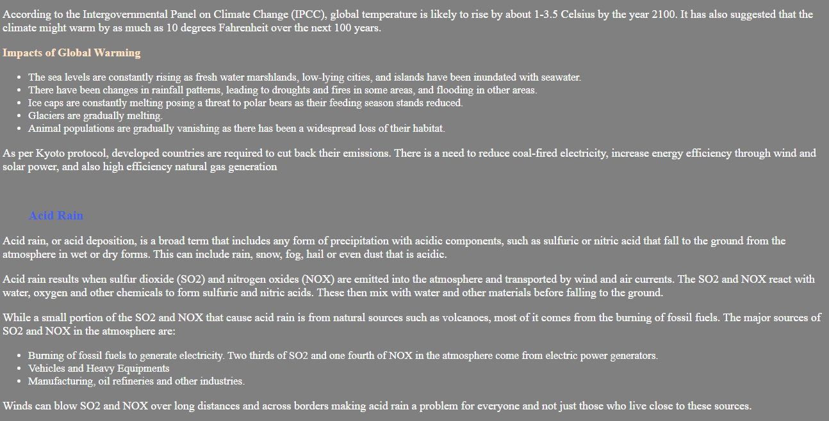

**Code 7: Sources of Energy**

Code:

<!DOCTYPE html>

<html>

<head>

<title>Sources of Energy</title>

<style>

table{

margin-left: auto;

margin-right: auto;

}

li,td{

font-size: 20px;

}

h1,h2,h3{

color: #89e5e8;

}

p{

color: #89bde8;

}

.c4{

color: #a589e8;

}

td{

color: #e889d8;

}

</style>

</head>

<body bgcolor="#321357">

<h1 style="text-align: center; font-family: Arial, Helvetica, sans-serif; font-weight: bold;">

SOURCES OF ENERGY

</h1>

<hr>

<p class="c1" style="font-size: 18px; color: #fff;">

<img src="https://images.ctfassets.net/0fol1oltsp9p/H4EkKlug0NpKkKED5fy3s/1ba87f1dcadfd61bf672fc537fb95957/Types_of_Renewable_Energy.jpg?w=920" alt="Sources-image" style="height: 300px; float: right;">

The <b>largest sources of energy </b> on

land is<b> sunlight</b>. There are

different purposes for which

energy is needed such as for food,

for lightning, transport, running

machines etc.

</p>

<h3 class="c2">

A good source of energy should be :-

</h3>

<ul class="c3">

<li class="c4">Cheap and Easily Available</li>

<li class="c4">Safe in Handling and Use</li>

<li class="c4">Do not Cause any Environmental Pollution</li>

<li class="c4">Easy to store and transport</li>

</ul>

<h2 class="c5"><u>MAIN SOURCES OF ENERYG:</u></h2>

<ol class="c6">

<li class="c7">

<p style="color: #cdcf67;">

<b>Conventional Energy - </b> Conventional energy sources are traditional

sources of energy like <b>Coal</b> and <b>Petroleum</b>.

</p>

<p style="text-align: center;">

<img src="https://www.greenchoices.org/wp-content/uploads/2011/03/Conventional_Energy1.jpg" alt="conventional-energy-images" style="height: 250px;"> <img src="https://mediaindia.eu/mig_2015/wp-content/uploads/2015/11/energy1.jpg" alt="conventional-energy-sources" style="height: 250px;">

</p>

<table class="c8">

<tr>

<td class="c9"><b>Advantages</b></td>

<td class="c9">

<ul class="c10">

<li class="c11">Energy Generation</li>

<li class="c11">Wider scope of the usage

of conventional source,

specially firewood.</li>

</ul>

</td>

</tr>

<tr>

<td class="c9">Disadvantages</td>

<td class="c9">

<ul class="c12">

<li class="c13">High Cost</li>

<li class="c13">Generates Pollution</li>

<li class="c13">Hydroelectric Plants</li>

<li class="c13">Exhaustible</li>

</ul>

</td>

</tr>

</table>

</li>

<li class="c7">

<p style="color: #cdcf67;"> <b>Non-Conventional Energy -</b> Natural <b>resources</b> like wind, tides, solar,

biomass, etc generate <b>energy</b> which is known as “<b>Non-conventional

resources</b>“.

</p>

<p style="text-align: center;">

<img src="https://anert.in/sites/default/files/styles/large/public/2016-12/slide01.png?itok=nfFy5Rzl" alt="non-conventional-image" style="height: 250px;"> <img src="https://3.imimg.com/data3/RO/KB/MY-12114407/images-solar-250x250.jpg" height="250px" alt="conventional">

</p>

<table>

<tr>

<td>

<b>Advantages</b>

</td>

<td>

<ul>

<li>Available in Nature</li>

<li>Free of Cost</li>

<li>Inexhaustible</li>

<li>Less Pollution</li>

</ul>

</td>

</tr>

<tr>

<td>

<b>Disadvantages</b>

</td>

<td>

<ul>

<li>High Cost of Harnessing Energy</li>

<li>Uncertainety of Availability</li>

<li>Difficult in Transporting</li>

</ul>

</td>

</tr>

</table>

</li>

</ol>

</body>

</html>

Output:

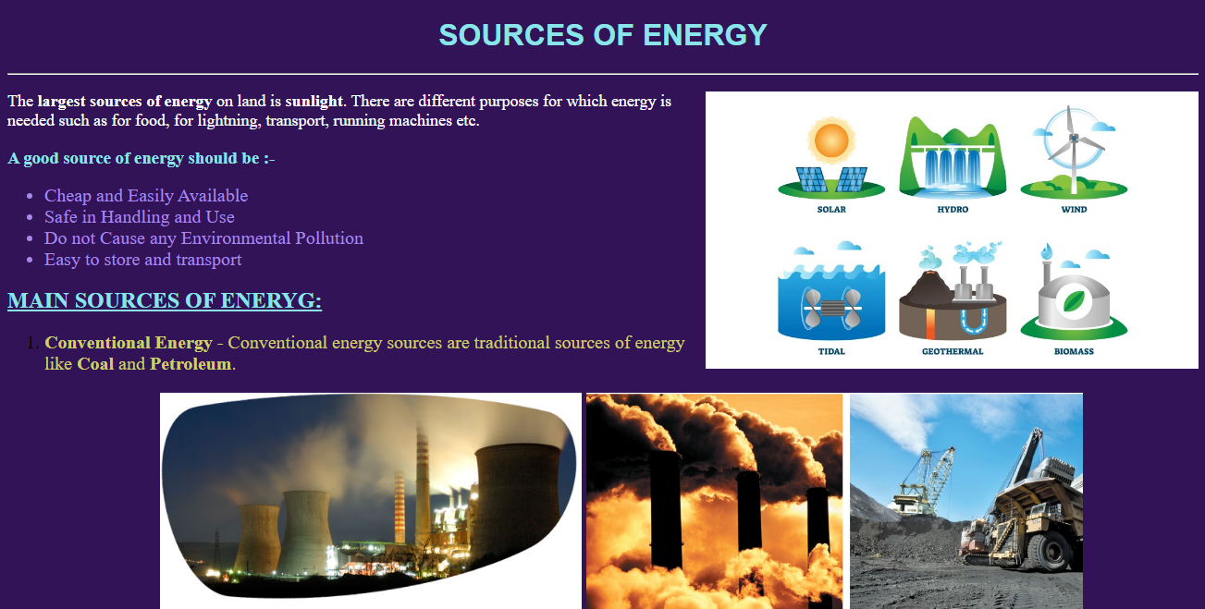

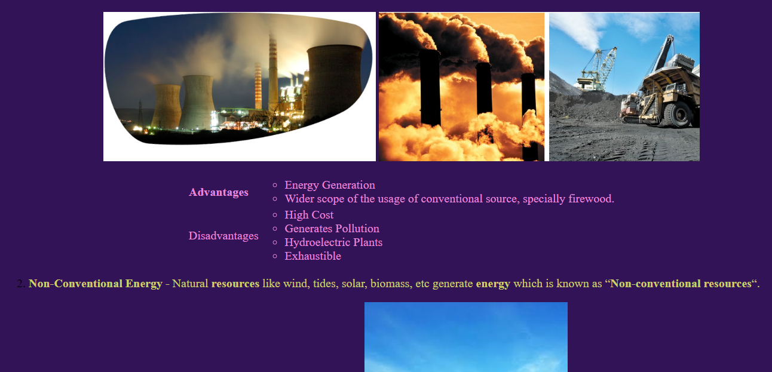

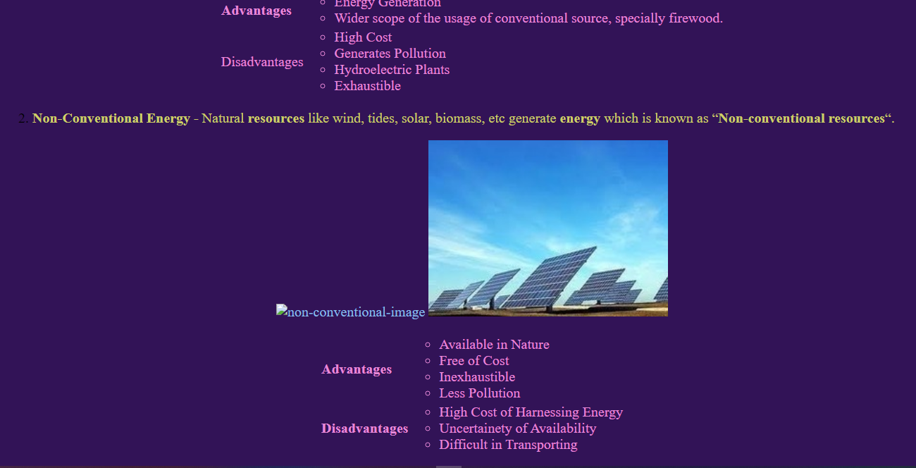

**Code 8 : Tours and Travel**

Code:

<!DOCTYPE html>

<html>

<html>

<title>Chandigarh Tours and Travels</title>

<style>

.he{

line-height: 0cm;

}

.al{

display: block;

margin-left: auto;

margin-right: auto;

height: 700px;

width: 700px;

}

.p-text{

font-size: 16px;

}

a{

text-decoration: none;

}

a:link{

color: rgb(224, 62, 224);

}

a:hover{

color: red;

}

p{

color: white;

}

</style>

</html>

<body bgcolor="black">

<p style="font-size: 20px; text-align: center;"><b>WELCOME TO CHANDIGARH TRAVEL AND TOURISM</b></p>

<p style="font-size: 20px; text-align: center;" class="he">FACTS - ABOUT - CHANDIGARH</p>

<img src="https://i.pinimg.com/originals/13/c6/af/13c6af77b212b3773e6c5c1e0a82b3c7.jpg" alt="I-Love-Changigarh-Image" class="al">

<p style="font-size: 18px;">

Chandigarh is the best planned city in India, woth architecture which is world-renowned, and a quality of

life, which is unparallel. As the capital of states of Punjab and Haryana, and the Union Territory

of Chandigarh. It is a prestigious city. The face of modern India, Chandigarh, is the manifestation of a dream that

Pt. Jawaharlal Nehru envisaged and <b>Le Corbusier</b> executed.

</p>

<p style="font-size: 18px;">

Chandigarhis the rare epitome of modernization co-existing with nature's preservation. India's first planned city, is a rich, prosperous, spic and span, green

city rightly called <b>THE CITY BEUTIFUL</b>.

</p>

<br><br>

<p><u><b>FOR FURTHER INFORMATION, CLICK HERE:</b></u></p>

<br>

<ol style="font-size: 17px;">

<li><a href="#Arc">Architecture</a></li>

<li><a href="#Gar">Gardens</a></li>

<li><a href="#See">Places to See</a></li>

<li><a href="#Eat">Eating Out</a></li>

</ol>

<h3 style="margin-left: 5px;" id="Arc">Architecture</h3>

<p class="p-text">

Chandigarh is planned by a famous architect, namely, Le Corbusier. Chandigarh is a very planned city with top class

architecture. Chandigarh is planned in a very systematic way. It is divided into several sectors, with mostly all

important facilities available in each sector. The city is very clean and looks very beutiful. The city also have

numerous parks in every sector.

</p>

<h3 style="margin-left: 5px;" id="Gar">Gardens</h3>

<p class="p-text">

Chandigarh is full of gardens. Some of the famous ones are Rock Garder and Rose Garden.

There are many more gardens like Japanese Garden, Terrace Garden, Garden to fragrance etc.

All the gardens in the city have thier own speciality. The whoe ROck Garden is made

up of only waste materials. It was made by Nel Chand. THe Rose Garden have all species of roses.

An annual festival known as the Rose Festival is also held here.

</p>

<h3 style="margin-left: 5px;" id="See">Places to See</h3>

<p class="p-text">

The city offers many Tourist places like Sukhna Lake, The very famous sector 17 and many more.

Sukhna lake is a very pleaseant place. The lake is very big and pleasant to visit early morning.

There also is a Doll Museum in Sector 15. Chandigarh also have a huge mall known as

Elante Mall.

</p>

<h3 style="margin-left: 5px;" id="Eat">Eating Out</h3>

<p class="p-text">

There are many places to eat in Chandigarh. There is a famous Street Food point near Punjab University

in sector-15. You can find some known restaurants in sector-35. Pal Dhaba is also very famous in the city.

Even you can find a good place to eat in each sector.

</p>

<img src="https://static.india.com/wp-content/uploads/2019/08/Elante-Mall.jpg" alt="image-elante-mall" style="height:400px;width:auto;border-radius: 20px;border: black 2px solid;vertical-align: top;">

<img src="https://upload.wikimedia.org/wikipedia/commons/2/25/Waterfall_at_Rock_Garden%2C_Chandigarh.jpg" alt="image-rock-garden" style="width: 600px;">

<img src="https://media-cdn.tripadvisor.com/media/photo-s/13/56/9f/6f/sukhna-lake.jpg" alt="image-lake-sukhna" style="width: 366;">

</body>

</html>

Output:

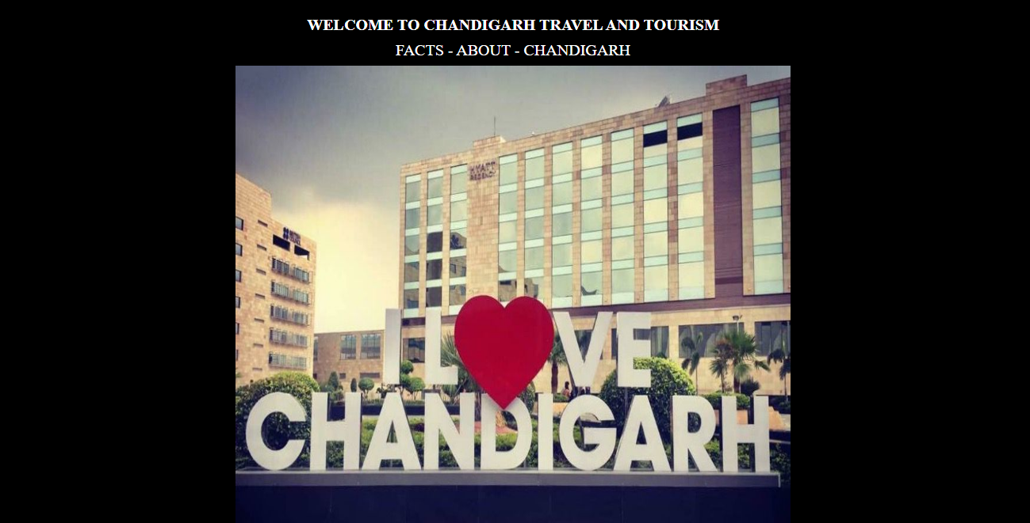

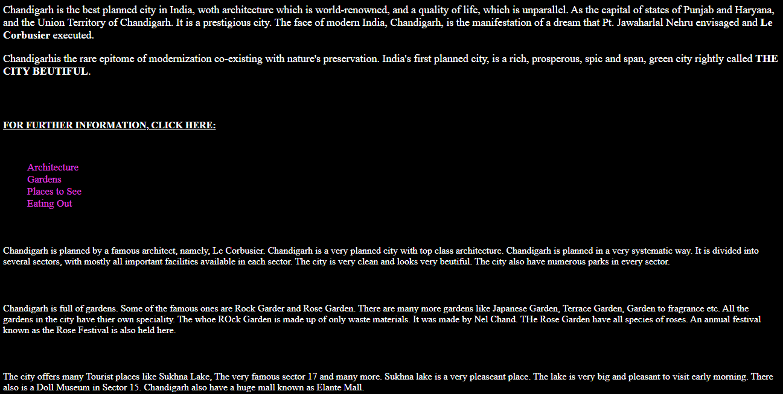

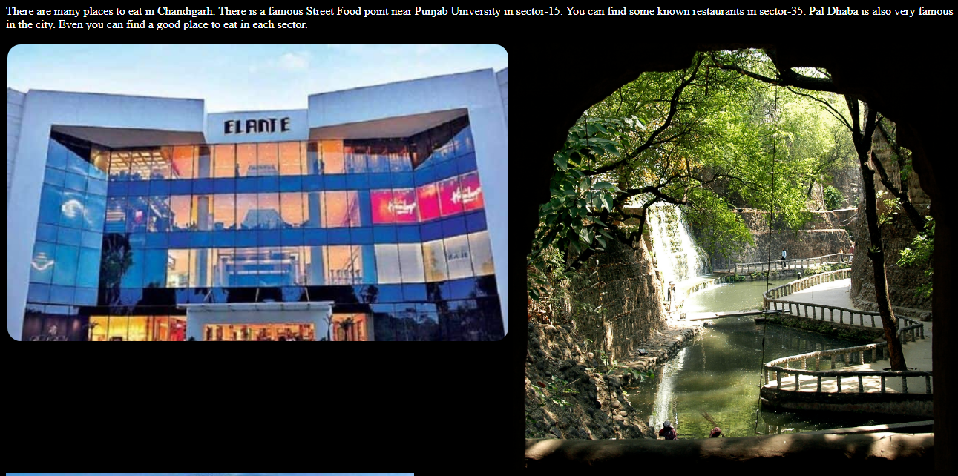

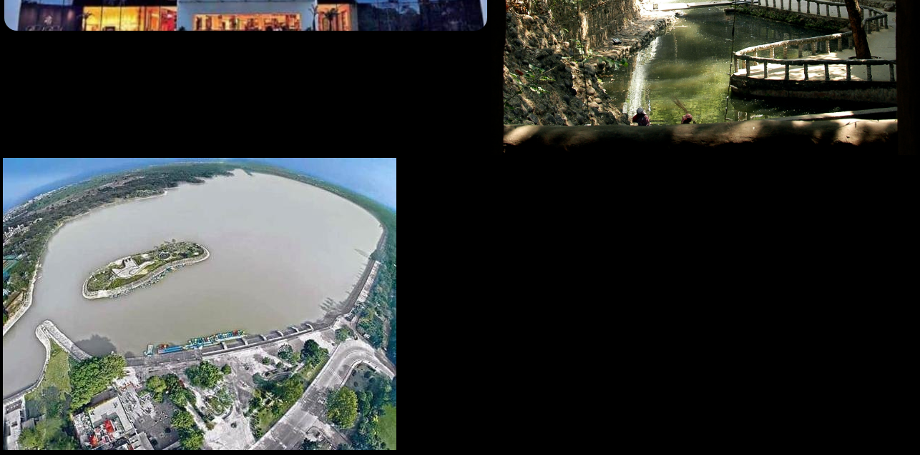

**Code 9: Virus**

Code:

<!DOCTYPE html>

<html>

<head>

<title>A blog on Virus</title>

<style>

p{

font-size: 16px;

color: aqua;

}

h2,h3{

color: white;

}

li{

color: rgb(74, 243, 52);

}

</style>

</head>

<body bgcolor="rgba(5, 3, 3, 0.322)">

<p style="text-align: center; size: 18px;">WELCOME TO E-BLOGGER.COM</p>

<h2>Let's Know More About:</h2>

<h2>VIRUSES:</h2>

<p> VIRUS stands for <i><u>VITAL INFORMATION RESOURCE UNDER SEIZE</u></i>. Virus is a program that

disrupts normal functioning of a computer. A virus infects or destroys data. Virus programs are self-

replicating. It enters into a computer without the user’s knowledge.

</p>

<h2>MALWARE:</h2>

<p>

The term malware is made up of two words, <b>MALICIOUS</b> and <b>SOFTWARE</b>. It is a software

that enters into a computer and damage it without user’s knowledge. Malware are trouble causing

programs. It may be virus, worm, Trojan horse or spyware.

</p>

<h2>SPAM:</h2>

<p>

Spam are unwanted bulk e-mails that come from unknown source. These are generally sent in

large number for advertising.

</p>

<h2>Protect your System from Malware:</h2>

<ol type="1">

<li>Always keep your system equipped with the updated antivirus software.</li>

<li>Do not use infected CDs or Pen drives on your system.</li>

<li>Be careful while surfing internet.</li>

<li>Keep your firewall turned “ON” that help to protect your computer from hackers.</li>

</ol>

<h2>Antivirus Software:</h2>

<p>

Antivirus softwareare computer programs which are designed to prevent and remove viruses fromcomputer.

</p>

<h3><dd>Some Popular antivirus software are:</dd></h3>

<ul>

<li>McAfee</li>

<li>AVG Antivirus</li>

<li>Quick Heal</li>

<li>Norton Antivirus</li>

</ul>

</body>

</html>

Output:

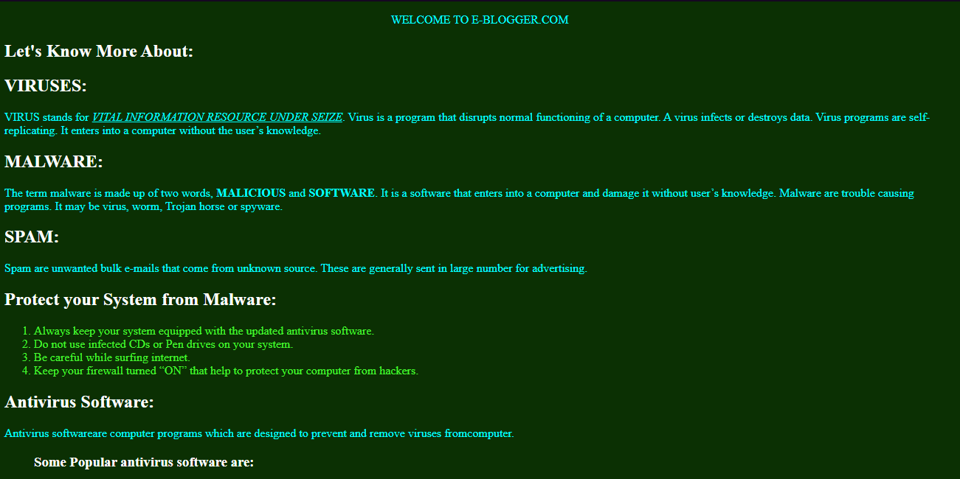



**Code 9: Wildlife**

Code:

<!DOCTYPE html>

<html>

<head>

<title>

Wildlife

</title>

<style>

p{

font-size: 18px;

}

</style>

</head>

<body bgcolor="black">

<h1 style="text-align: center; font-family: Copperplate; color: gray;">Wildlife - A Definition</h1>

<hr>

<p style="color: cadetblue;">

Wildlife traditional refers to <b>non-domesticated animal</b> species, but has

come to include all plants, fungi, and other organisms that grow or

<b>live wild</b> in an area without being introduced by humans. It can be

<b>found in all ecosystems</b>. Deserts, forests, rain forests, plains, grassland

and other areas including the most developed urban sites, all have

distinct forms of wildlife.

</p>

<p>

<img src="https://previews.123rf.com/images/saddako/saddako1303/saddako130300074/18551556-a-collage-of-wild-animals-and-birds.jpg" alt="" style="float: right; height: 400px;">

<img src="https://m.media-amazon.com/images/I/61Q7R-Wc5XL.jpg" alt="animals-image-collage" style="float: right;">

<ul>

<li>

<a href="https://support.wwf.org.uk/adopt-an-animal" style="font-size: 20px;">Adopt an Animal</a>

<ol>

<li><a href="https://support.wwf.org.uk/adopt-a-tiger" style="font-size: 18px;">Tiger</a></li>

<li><a href="https://support.wwf.org.uk/adopt-an-elephant" style="font-size: 18px;">Elephant</a></li>

<li><a href="https://nywolf.org/adopt-a-wolf/" style="font-size: 18px;">Wolf</a></li>

<li><a href="https://www.bornfree.org.uk/adopt-a-giraffe" style="font-size: 18px;">Giraffe</a></li>

<li><a href="https://support.wwf.org.uk/adopt-a-leopard" style="font-size: 18px;">Leopard</a></li>

</ol>

</li>

<li><a href="https://www.nwf.org/Educational-Resources/Education-Programs" style="font-size: 20px;">Wildlife and Education</a></li>

<li><a href="https://news.mongabay.com/list/wildlife/" style="font-size: 20px;">Latest News and Events</a></li>

<li><a href="https://www.pexels.com/search/wildlife%20photography/" style="font-size: 20px;">Photos Gallery</a></li>

</ul>

</p>

</body>

</html>

Output:

